Scripture(s): Mark 14:12-25 (NLT)

Terms to Define:
- Passover – Commemorates the Israelites deliverance from over 400 years of Egyptian bondage. ^{A} More specifically this feast commemorated the night when the death Angel “passed over” the homes of all Israelites who took the blood of a lamb and sprinkled it over their doorpost, sparing the lives of their firstborn people, and putting to death the first born Egyptians and their livestock. The lives of Israelite firstborn people and livestock were protected by the sacrificial blood. It was a celebration of God’s acts in delivering Israel from Egyptian slavery (Exod. 12 & 13). It was in the first month of “Abib”. Passover was to be held on the 14th of the month, the date of the original Passover celebration (Exod. 12:6). Passover comes from the verb pasha meaning “to pass over.”
- Passover (Seder) Meal – Seder is a Jewish ritual service and ceremonial dinner for the 1st night or 2 of Passover. Jesus taught his disciples that the wine and the bread served at the Passover meal signified that he would become the sacrificial lamb by which sins are forgiven and reconciliation with God can occur.
- Last Supper – is not mentioned in the Bible, but it is a phrase used to describe the last meal Jesus had with his disciples (Matt. 26:26-29; Mark 14:22-25; Luke 22:15-20; John 13:1 & 2, -17:26; 1 Cor. 11:23-26).^{A} The Last Supper and Passover Meal are one in the same.

Act | Explained | Symbolism
Passover  (Thursday 6pm to Friday 6pm) | - Night when the death Angel “passed over” the homes of all Israelites who took the blood of a lamb and sprinkled it over their doorpost, sparing the lives of their firstborn people, and putting to death the first-born Egyptians and their livestock. The lives of Israelite firstborn people and livestock were protected by the sacrificial blood.  - As a commemorative rite the Israelites were to use the Passover to teach their children about God’s miraculous deliverance from Egypt.  - Passover sacrifice was originally either a year-old sheep or goat. | The event foreshadowed the coming day when all humanity would be offered deliverance from slavery to sin and eternal death through the blood of Yeshua, the Lamb of God.
Passover Meal  (Thursday evening between 6pm-12am Friday) | This feast commemorated the night when the death Angel “passed over” the homes of all Israelites who took the blood of a lamb and sprinkled it over their doorpost, sparing the lives of their firstborn people, and putting to death the first-born Egyptians and their livestock. Passover meal typically consisted of lamb, bread, and wine.  The Passover Meal is eaten same day as the first day of Unleavened Bread, the 15th, but starting between the 14th and 15th. The Mosaic Law stipulated what day the Passover lamb was to be eaten: Nissan 14 (Num. 9:2 & 3). We must assume that Jesus kept the Law and observed Passover at the appointed time (Gal. 4:4).  Even though Passover and Unleavened Bread were traditionally two separate celebrations and feasts, Passover became closely linked with the Feast of Unleavened Bread. Later texts used the names and lengths of the celebrations interchangeably. Thus, it’s common to refer to Passover as a week-long festival like the Feast of Unleavened Bread. | Jesus taught his disciples that the wine and the bread served at the Passover meal signified that he would become the sacrificial lamb by which sins are forgiven and reconciliation with God can occur. Jesus = ; Bread = ; Wine =
Last Supper  (Thursday evening between 6pm-12am Friday) | Is not mentioned in the Bible, but it is a phrase used to describe the last meal (Passover Meal) Jesus had with his disciples (Matt. 26:26-29; Mark 14:22-25; Luke 22:15-20; John 13:1 & 2, -17:26; 1 Cor. 11:23-26). | Jesus used the last supper to prepare the disciples for what he must go through and suffer the following day (Day of Preparation for the Sabbath).

Galatians 4:4

“4 But when the right time came, God sent his Son, born of a woman, subject to the law. 5 God sent him to buy freedom for us who were slaves to the law, so that he could adopt us as his very own children. 6 And because we are his children, God has sent the Spirit of his Son into our hearts, prompting us to call out, “Abba, Father.” 7 Now you are no longer a slave but God’s own child. And since you are his child, God has made you his heir.”

Passover Timeline:
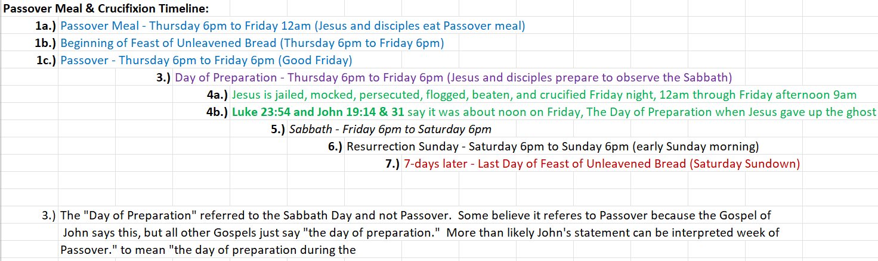

Resource(s):

- Holman Illustrated Bible Dictionary

