SCRIPTURE(S)
Matthew 13:24-30,

Matthew chapter 13 has the most parables than any other chapter in Matthew, and any other Gospel with a total of 8 parables.

PARABLE
Background:
Where is Jesus as he tells these parables? Matthew 13:1-3

What are weeds and what is wheat?

Weeds & Wheat growing together:

Wheat starts off as a green color:
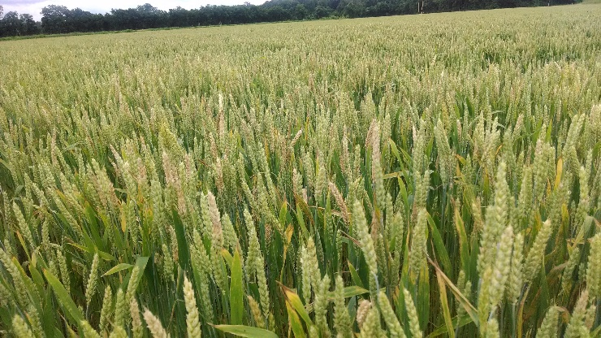

Head of Wheat:
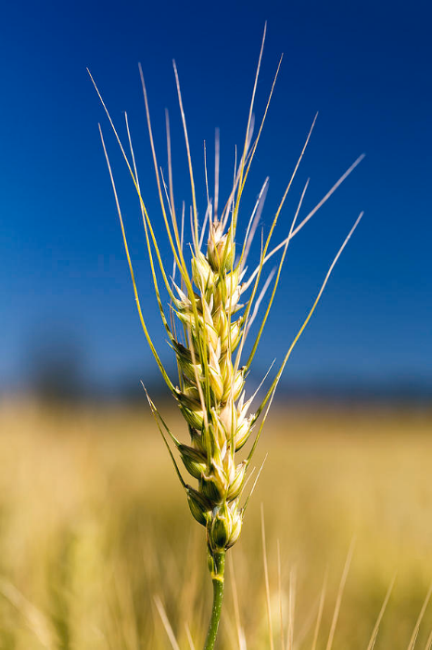

As wheat ripens and is ready for harvest it turns a brownish color:
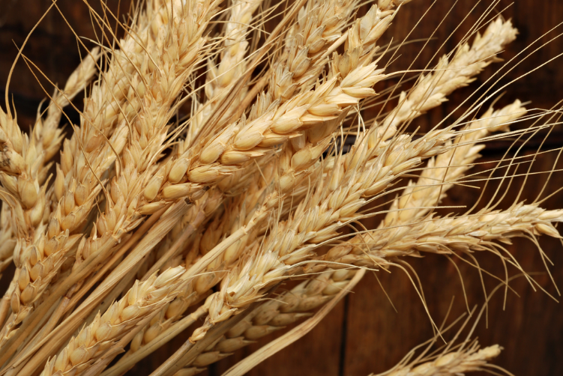

What does this parable mean?

Synopsis:
Matthew 13:36-43 (Apocalyptic Parable or prophecy describing the destruction of the world)
Jesus shares with the disciples what the Parable of the Weeds mean. What or who does each of the nouns below represent in the parable?

Field Owner =
Field =
Good Seed (Wheat) =
Bad Seed (Weeds) =
Enemy or Bad Man =
Harvest =
Reapers =

When the end to this world as we know it comes, the Son of Man will send his angels forth into this world (his Kingdom) to gather (remove) everything that causes sin and all who do evil (“they will weed out of his kingdom” - NIV). “Then the righteous will shine like the sun in the kingdom of their Father. Whoever has ears, let them hear.” The last phrase John the Revelator quotes at least 8 times in Revelation.

This reminds me of the passage in Revelation 11:15-18.

What conclusion do you come to after reading and hearing this parable?

Conclusion:

