**Tabernacle Series**

Date: May 5, 2025

By: Elder Percy Woods, Jr

**Must Start with the Fall of Man and Then the Priests:**

* Fall of Adam & Eve – Lost the Presence of God!
* Luke 3:23, 38 – Adam was the first son of God, but after the fall of man in the Garden, God no longer referred to us as the Sons of God, He referred to us as “Son of Man.”
* The Question is, “***How do we get back the presence of God and the title of Sonship?”*** ====🡺 **Answer: The Tabernacle**

**To Fully Examine the Tabernacle, Must Start With The Priest First: Tabernacle Without the Priesthood Would be Barren & Void**

* Exodus 30:30 – Aaron & his descendants (sons) were anointed to serve as Priests. We called of God!
* Hebrews 5:1-6 – No man takes this honor of the priesthood unto himself. Has to be called by God.
* Numbers 18:6-7 – Levites are gifts from God to the People, dedicated to the Lord for service

1. Tabernacle
   1. Exodus 25:1-9 - Freewill Offering to Set Up the Tabernacle
   2. Numbers 7:1-3 – Moses Anoints and Sanctifies Tabernacle – Consecrated (Set Apart) - Holy Place
   3. Exodus 40:1-15 – Brief Description of How Everything in the Tabernacle was Anointed Along with the Everlasting (Ongoing) Priesthood of the Next Generation.
2. Door of the Tabernacle
   1. Exodus 26:36 – 37 – The first place you come to is the door of the

Tabernacle

* John 10:9 – Jesus said, “I am the door: by me if any man enter in, he shall be saved.”
* The First Step in Getting Back to God is to Come to Him, Come to Jesus, Come to His House, Enter in at the Door (Forsake Not the Assembling of Yourselves).
* Notice the Color of the Door (Symbolism)

a.) **Red** – Symbolic of the Blood of Jesus.

b.) **Blue** – Symbolic of Heaven (Look up towards Heaven, you see blue) ====🡺 Jesus said He came down from Heaven. Blue symbolizes Jesus’ divinity.

c.) **Purple** - Purple is symbolic of royalty … Divine Royalty (a king’s royal robe). Also, purple is a blend of red (blood) and blue (sky), representing a combination of the human side of Jesus as well as his divine side (Christ has dual natures … He’s fully man, yet fully God)

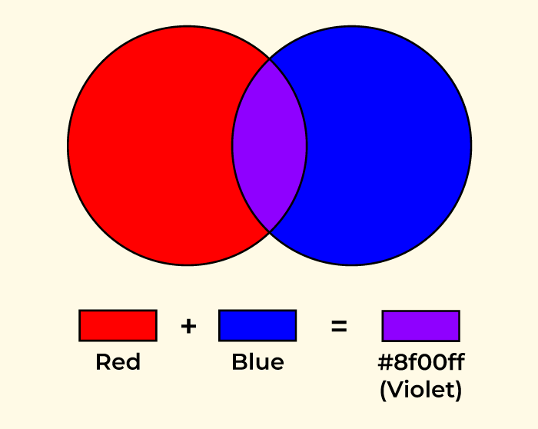

* This is Something That Job Prayed For …
* Job 9:28-33 – Job is saying that in order for me to be saved from my sin, I need a mediator … someone who is Holy enough to touch God, yet human enough to touch me! This was fulfilled in Jesus, for He is fully God, yet He is fully man. He’s the perfect mediator!
* **We see a foreshadow of this in Job 33:6-7** – Elihu says, “I am according to they wish …”

**The Blood of Jesus Brought Peace Between God & Man**

**Sin Brought Contention Between God & Man**

 

The First Thing God Wants us to Know is That it is He Who Came Down from Heaven to Die for Our Sins (**Acts 20:28**)

* The Colors of the Door Tell Us From the Beginning That God Came Down to Save Us

The Door of the Tabernacle and its color are a foreshadow of this.

1. Brazen Altar of Sacrifice
   1. Exodus 27:1-2, 6-7
   2. Offered the Sacrifice here – foreshadow (sneak preview) of Christ’s sacrifice
   3. Alter – Signifies to “Lift Up” (The Place of Lifting Up)

* John 12:32-33 – If I be lifted up from the earth…
* Leviticus 9:22 – If Aaron had to “***Come Down***” from the Altar of Sacrifice, then that means to offer the sacrifice, he had to “***Go Up!***”
* The Altar of Sacrifice is an elevated place. One of the meanings of the word altar is “High Place.”
* Leviticus 6:12-13 – The fire on the altar could “***NEVER***” go out. The fire on the altar, which was continually burning, had a threefold meaning:

1.) Foreshadow of Christ’s eternal offering for our sins.

2.) Was symbolic of God’s continual readiness to receive any man who repented. The sacrifice of Jesus is always available to anyone who will receive Him.

3.) The Sin Offering of Jesus’s body should continually be on our minds, wherein we give thanks. This is why the Bible says, “Enter into His gates with thanksgiving!” It’s because the first thing you see in the Tabernacle is the sacrifice of Jesus, and we, therefore, should praise Him continually, always, for what He has done!!

**Side Note:** After Jesus ascended into heaven, He sent the Holy Ghost to light the fire on the altars of our hearts (John said He that cometh after me shall baptize you with the Holy Ghost and with Fire) ====🡺 Heb. 1:7 – He makes His Ministers a “***Flame of Fire!***” When you start talking about Jesus, there ought to be some Fire that comes out of you!

**Side Note**: This “***Consuming Fire***” was initiated by God (Leviticus 9:22-24) – God ignited the wood and consumed the whole sacrifice ===🡺 This Fire I have inside of me didn’t come from me, it came from God! So don’t judge my praise when I jump out of my seat and run all around the Church!

**Side Note**: Jonah 2:9 - Fire came from God/Salvation is exclusively of the Lord.

* **Moses & the Serpent: John 3:14-15** - And as Moses lifted up the serpent in the wilderness, even so must the Son of man be lifted up: That whosoever believeth in him should not perish, but have eternal life.

a.) Numbers 21:4-8 – And it came to pass, that if a serpent had bitten any man, when he beheld the serpent of brass, he lived.

b.) Direct Correlation Between Christ and the serpent.

c.) The brass was beaten into the shape of a serpent, which was then placed on a stick. Christ was beaten and then placed on a cross. Both the beaten serpent and the beaten savior were lifted up.

d.) But, why this correlation, especially when the serpent is the “**Symbol of Evil**”, the “**Symbol** **of SIN?**” The answer is in the symbol of medicine …

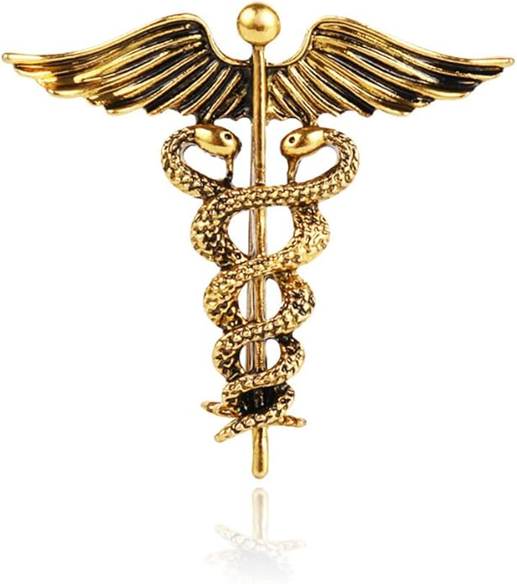 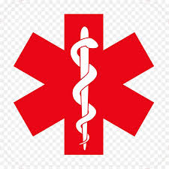

e.) If you get bitten by a poisonous snake, how do you get healed? What is the antidote to a snake bite? The antidote to a snake bite is in its own venom. The cure is in what bit you!

f.) The bible says that He that knew no sin became sin for us. Jesus became the thing that bit us so that He could cure us!! He became what He hated the most (SIN), knowing that the only way to save us was to cure us by what bit us. And when He became SIN on the cross, God “***Judged the Sin***” with His Fiery Wrath and consumed the sacrifice!

g.) What do they put in the FLU Vaccine? The answer is, ***“The FLU!”*** This medical concept is not new, for the Bible says, ***“There’s Nothing New Under the Sun!”*** Doctors often use what’s ailing you to cure you, something they got from the Bible!

h.) In the Earth, God will often use you to help cure other people who are going through something you already went through. The very thing that killed you will cure others!

* 1. Exodus 27:1-2 - The Four Horns of the Altar

1.) The Horns of the Altar provided a refuge for fugitives. Those who caught hold of the horns of the altar were typically granted asylum.

2.) I Kings 1:50-53 – Solomon’s brother, Adonijah tried to secretly steal the throne from Solomon. When he found out, Adonijah ran and grabbed hold of the Horns of the Altar as a plea for mercy from the King.

3.) The Altar is the place we come to for mercy, asking God to forgive us of our sins!

4.) The Horns of the Altar pointed in all directions **N, E, W, S** **(Good News!!)**. The Gospel is to be preached to every nation in all corners of the earth. God stands ready to forgive those who have trespassed against Him.

5.) Leviticus 17:11 – “For it is the Blood that maketh atonement for your souls.” ***Thank God for the Blood!***

1. The Brazen Water Laver
   1. Exodus 30:17-21 – Had to wash so they wouldn’t die. This was a statue (Law) that would last forever. This statue would never change. The Levites/Priests had to wash to keep from being dirty (We are all Kings & Priests now, therefore, we all have to wash). What is the one thing that makes us all dirty in the eyes of God? ===🡺 **SIN!** **The Brazen Water Laver was Symbolic of Washing Away Sin.**
   2. Acts 22:16: And now why tarriest thou? arise, and be baptized, and wash away thy sins
   3. **Brazen Laver Was Prophetic of the Coming Baptism.**
   4. Exodus 38:8 – Also made from mirrors (***Self Reflection***). The Word of God is a mirror that will force you to admit that you’re a sinner and need to be washed and cleansed from sin.
   5. **How Do We Get Cleansed?**
      1. I John 1 - But if we walk in the light, as he is in the light, we have fellowship one with another, and the blood of Jesus Christ his Son cleanseth us from all sin.
      2. Hebrews 9:22 – Without the ***shedding of blood***, there is ***no remission of sins***
      3. Acts 2:37-38 - Therefore let all the house of Israel know assuredly, that God hath made the same Jesus, whom ye have crucified, both Lord and Christ. Now when they heard this, they were pricked in their heart, and said unto Peter and to the rest of the apostles, Men and brethren, what shall we do? Then Peter said unto them, Repent, and be ***baptized*** every one of you in the name of Jesus Christ for the ***remission of sins***, and ye shall receive the gift of the Holy Ghost.
      4. Acts 22:16: And now why tarriest thou? arise, and be baptized, and wash away thy sins
      5. How Do We Get Cleansed? The Blood of Jesus and the Baptism in His Name. ***The Blood and the Water Go Hand-in-Hand Together!***

John 19:34-35 - But one of the soldiers with a spear pierced his side, and forthwith came there out ***Blood and Water***.

1 John 5:6 - This is He that came by ***Water and Blood***, even Jesus Christ; not by water only, but by ***Water and Blood***.

Israel Coming Out of Egypt – What was their avenue of escape? ***The Blood*** was applied to the doorpost.

But Pharaoh Was Still After Them – When was it that Pharaoh was destroyed? When they went through ***The Water*** (foreshadow of baptism, prophetic of baptism). I Corinthians 10:1-2 says, “Moreover, brethren, I would not that ye should be ignorant, how that all our fathers were under the cloud, and all passed through the sea; And were all ***baptized*** unto Moses in the cloud and in the sea;

Galatians 4:22-24 – There are allegories all throughout Scripture. Allegories are stories that shed light on a spiritual meaning. So, how do allegories relate to the Blood and the Water Baptism?

**Matthew 25:1-12** – **Allegorical story of the 10 Virgins** … All 10 were clean (We’re looking at 10 baptized believers in Jesus’ sacrifice). But, only 5 had oil in their lamps (had the Holy Ghost). When the Bridegroom (Jesus) came back in the rapture, only those with the Spirit of God were caught up. We know this is true based on Romans 8:11 - But if the Spirit of him that raised up Jesus from the dead dwell in you, he that raised up Christ from the dead shall also quicken your mortal. The allegorical story or parable of the 10 virgins leads us to …

Matthew 22:1-14 – Jesus cast out His own friend … Why? Because he didn’t have on his wedding garment! This wasn’t some sinner that was cast out; it was His friend! This tells us that whatever this wedding garment is, is something very important.

**What is This Wedding Garment?**

* **Revelation 7:9** - After this I beheld, and, lo, a great multitude, which no man could number, of all nations, and kindreds, and people, and tongues, stood before the throne, and before the Lamb, clothed with ***white robes***, and palms in their hands;
* **Revelation 7:13-14** - And one of the elders answered, saying unto me, What are these which are arrayed in ***white robes?*** and whence came they? And I said unto him, Sir, thou knowest. And he said to me, These are they which came out of great tribulation, and have ***washed their robes***, and made them ***white in the blood of the Lamb.***
* **Revelation 19:7-9** - Let us be glad and rejoice, and give honour to him: for the marriage of the Lamb is come, and his wife hath made herself ready. And to her was granted that she should be arrayed in fine linen, clean and white: for the fine linen is the righteousness of saints. So, the Bride of Christ has on a White Robe that’s been washed (Baptism) and made white in the Blood of the Lamb.
* The wedding garment this man was supposed to have on is the Baptism in Jesus Name! In other words, this man’s sins had not been washed away. He was still dirty in the eyes of God. Remember, the Blood and Water both go together.
* Notice that the man was ***“Speechless!”*** Why was he speechless? It’s because he had heard this before and, for whatever reason, chose to ignore it.
* The Baptism in Jesus’ Name, along with the Blood, is the Wedding garment we all need to have on.
* Is there anyone on earth who can be a part of the wedding ceremony without a wedding garment? Can the bridesmaids or groomsmen be a part of the wedding in beach attire (flip flops and shorts?). The answer is no. We have all been “Called to the Marriage Supper of the Lamb” and therefore need to have on the proper attire! ====🡺 **The Blood & The Water Baptism.**